**HO TECHNICAL UNIVERSITY**



**FACULTY OF APPLIED SCIENCES AND TECHNOLOGY**

**DEPARTMENT OF COMPUTER SCIENCE**

**DESIGN AND DEVELOPMENT OF EDUCARE MANAGEMENT SYSTEM FOR GOLDENINTELS EDUCARE CENTER**

**BY**

**MOHAMMED, Abdul Karim (03170104)**

**DOGAH, Andrews Ofori (03172228)**

**MANU, Kweku Dominic (03172355)**

**BEKOE, Fred Kwesi (03172221)**

**BONSU, Emmanuel (03172224)**

**MAY, 2020**

TABLE OF CONTENTS

CHAPTER ONE 3

INTRODUCTION 3

1.1 Background of the Project 3

1.2 Statement of the Problem 6

1.3 Aim and Objectives of the Project 6

1.4 Significance of the Project 7

1.5 Scope of the Project 7

1.6 Limitation of the Problem 7

1.7 Organisation of the Problem 7

CHAPTER TWO 9

LITERATURE REVIEW 9

2.1 Review of Related Works 9

2.2 Review of Related Systems 10

2.3 Existing Systems 14

2.3.3 Problems Existing System 15

CHAPTER THREE 16

DESIGN AND DEVELOPMENT 16

3.1 Proposed System 16

3.2 System Specifications 16

3.3 Selection of Technology and Tools 17

3.4 System Architecture Design 18

3.5 Design of the System 19

**TABLE OF DIAGRAMS**

Diagram 1: Prototype model 18

Diagram 2: Architecture Design 19

Diagram 3: Flow chart 20

Diagram 4: Use case 21

Diagram 5: ER Schema 22

# CHAPTER ONE

## INTRODUCTION

### Background of the Project

Day care refers to the care provided for infants and toddlers, pre-schoolers, and school-aged children, either in their own homes, in the home of a relative or other caregiver, or in a centre-based facility. Day care centre is normally supervised daytime care for preschool children, the elderly, or those with chronic disabilities, usually provided at a centre outside the home. Day care is a specialized program or facility that provides care for handicapped or dependent children or adults as a substitute for or an extension of home care. There are two types of day care: An adult day care centre, also commonly known as adult day services, is a non-residential facility specializing in providing activities for elderly and/or handicapped individuals. Most centres operate 10 - 12 hours per day and provide meals, social/recreational outings, and general supervision. Adult day-care centres operate under a social model and/or a health care model (Berenbeim, R. E., 1992). Adult day care includes programs, services, and facilities designed to assist physically or mentally impaired adults remain in their communities. Adult Day Care Centres offer social, recreational and health-related services to individuals in a protective setting who cannot be left alone during the day because of health care and social need, confusion or disability (Shonkoff, J. P., & Philips, D.A.; 2000). Most programs include an individualized plan of care, group exercise, adult education classes and recreation, nutritious meals, and social work services. In addition, these programs make respite for caregivers possible, and provide support groups for participants and caregivers. Child day care is a place where children, usually, are taken care of people other than their parents for money from the parents. It is specialized program or facility that provides care for children from infants through preschool age, usually within a group framework, either as a substitute for or an extension of home care. It is caring for and supervising child/children by someone other than the parent or guardian.

During the eighteenth to nineteenth centuries, parents in the Bangladesh rarely had to face the problems of child-rearing alone because they could usually expect support from their extended families, many of whom lived and worked close by, and mothers or close relative of mothers. Urbanization and changing social conditions in the twentieth century created a need for child care for poor mothers who had to work and child day-care centres were first come to Bangladesh. Such centres generally provided care only for poor children. More affluent mothers rarely worked, and, if they did, they hired nannies to look after their children. With the passes of time, garments sector in Bangladesh are developed and aged or under aged girls are greatly involved with jobs. Moreover, female education rate is increasing day by day and thereby women working rate. The severe scarcity of house maid led to the demand of child day care centre. Thus, the physical environment can either contribute to children's development and support staff and parent goals or create a permanent impediment to the operation of a high quality program. Designing a high-quality, developmentally appropriate child care facility is a highly complex task which requires specialized and unique skills. The design and layout of the physical environment, which includes the building, interior finishes, outdoor spaces, selection of equipment and room arrangement has a profound impact on children's learning and behaviour and on teachers' abilities to efficiently do their jobs (Smith and Bob, 1991).) Children need age-appropriate physical environments that support and promote child directed and child-initiated play. The environment must promote and positively support the child's interaction with space, materials and people. Teachers and caregivers also need highly functional, easy-to-use environment. The early years of a child’s development are very important not only because they lay the basis for human development but also because experiences children are exposed to during that period have lasting influence in childhood. Successful early childhood care and stimulation programmes lay the foundation for creativity, imagination, self-reliance and survival of the child (Asenso-Boakye, 2005). A person’s future potential is better exploited when proper attention, care and support are accorded as early as possible in one’s life.

Empirical research findings indicate that the nature of care given to children in the first eight years is directly linked to an individual‘s health and productivity during childhood, and to the socio-economic development of society as a whole (Fogel, 1994). The success of children in school to a large extent determines their success as adults, determining whether they can go to college, what professions they enter, and how much they are paid (Asenso-Boakye, 2005). Early childhood Education provides a nurturing atmosphere which nourishes young imaginations and instils self-confidence in the children.

Management information systems has helped in Edu-care at large. It has made operations and interaction become easier for the mistresses and parents who have wards in the day-care centres.

There has been many educare centres in recent years. Most of these schools admit children from the ages of three months after birth to five years. Most mothers who work in the government sectors and other workplace normally take their children to these day care schools before they go to work, and come for them after they close from work. The mistresses in charge take care of the children while they are brought. Here, parents have to call the mistresses to know how their wards are doing despite their busy schedules at work. Mistresses sometimes call parents individually when any information is to be passed to parents. This is hectic and time consuming as well. When children’s stuff that is baby foods, grip water and other essentials are finished, the mistress will have to call the parent and inform them or wait till it’s pick up time before they are told. This is a challenge too.

This Android Based and web based application will tend to make communication between the mistress and the ward’s parent easier. With this application, the application will be made available on the Google Play store. So parents will download it on their phones, whilst the mistress will have a Web application for which she will be the administrator .She will send messages and alerts to parents .Notifications will be sent to the them as well .It will be interactive. So parents will now know the welfare of their wards throughout the day .Reports will be sent to the mistress and feedbacks will be accepted from the parents.



### Statement of the Problem

Students records are mixed up because there is no efficient system in the school .At Golden Intels Educare, data stored for pupils is not properly stored because, the system used to carry these actions is not efficient and reliable. Data stored on it can most of the times cannot be retrieved. Also parents do not get daily reports of their wards. Every parent will like to get daily reports of their wards. If they slept well, ate well and all. So as to help them monitor the growth of their ward. Unfortunately, they don’t get daily reports.

### Aim and Objectives of the Project

**Aim**

The aim of this project is to develop a web and android application for Golden Intels Educare

**Objectives**

* To design a database to store child’s data.
* To design a friendly user interface they can interact with.

### Significance of the Project

**Parents**

With the help of this system, parents will interact better with the care-taker, to know how their children are doing. They would not have to always call her for information because messages, reports and others information would be sent through the system, as well as feedbacks.

**Care-taker**

The care-taker who is in charge, and the same time the administrator, will now have less work to do. Thus, passing information to the parents will be much easier. Example when a child is under the weather, or when their supplements and others materials are getting out of stock, the mistress will notify them through the app.

### Scope of the Project

This Educare Management System is an Android and Web application that will involve two entities which are the care-taker and the parent. This system will used by Golden Intels Educare.

### Limitation of the Problem

### Organisation of the Problem

The project has been categorized into five folds which are Chapter One, Chapter Two, Chapter Three, Chapter Four and Chapter Five.

**Chapter One**This chapter deals with the General background of the project, the aims and objectives, the problem statement and the significance of the project.

**Chapter Two**This chapter deals with the literature review, features of the project, drawbacks, benefits and the existing system.

**Chapter Three**This chapter deals with the proposed system, system specifications, functional requirements, non-functional requirements, tools and technologies and the architecture and design of the system.

**Chapter Four**  
Chapter four deals with the design and implementation of the system. This is where the system is developed, testing and possible corrections are done on the system.

**Chapter Five**Chapter five deals with the conclusion and possible updates

# CHAPTER TWO

## LITERATURE REVIEW



### Review of Related Works

In the way of life, for anyone to start something new, there are people out there who have already said or/are saying something about it. This can be a guide to help one to know how to carry out his/her project successfully and also, it can be a caution to prevent one from risking his/her life and resources.

Concerning our project (Educare Management System), we made research on researched projects. Thus, what people are saying about it and the best way to go about the project. One researcher carried out a research project concerning Communicating Risk to parents about their children. In carrying out the project, he find out that, the administration risk communication of children to their parent was inadequate. Thus, the information reaching the parents is not enough and also the medium through which the information reaches the parents was very poor. The common medium used to communicate risk to parents was in form of written documentation. But schools who uses technological medium such as website were only two. In conclusion to the researcher’s project, there should be many mediums through which risk communicator can reach parents. Also risk communication should be considered as a serious issue by the communicator. (Dallat, 2007)

### Review of Related Systems

There are lots of systems that relate to this project. Numerous attempts have been made to develop tools and techniques to enhance the management of Educare centres. These systems includes Smart Educare. The Smart Educare is a web application (accessible only on the internet) software specially designed for primary and secondary education. This system was designed to help manage operational data. This system does have a mobile application. All users must visit the web site before they can use. (Ltd., n.d.)

In addition, TAD Educate is also a web application (accessible only on the internet) which is not customized for a specific school but is a general web application which any school can use the system at the same time. This system is consist of managements, enrolment, admissions, financial aid, and school management for private and public schools. All a school needs to do is to create an account with its details. (TADS, 2002)

Lastly, Childcare is web application (accessible only on the internet) which was designed and developed to enhance the parents and caretakers communication the mobile technology. Thus, this system is a medium through which parents can communicate with caretakers everywhere provided if only there is internet. Also it was designed to support student achievement and parental involvement. (Tadpoles, 2010)

#### **Features**

Some features of Smart Educare are as follows:

* + - Administrator Module: The administrator has full control over the system. Thus, the administrator can view, edit, create and delete users of the system
    - Teachers Module: Teachers has a dashboard that they can view students and class information in details.
    - Students Module: The students has a dashboard that they can view class routine and other information about class.
    - Parents Module: The parent can also view class routine, they can know about teachers’ information and contacts. Also they know all parents who have their children in the school.

Some features of TADS Educate are as follows:

* + - Cafeteria Management: This allows a user to management food system.
    - Curriculum Management: This allows assess and adjust curriculum.
    - Financial Management: This allows one to manage the monetary aspect being school fees and other expense.
    - Online Calendar: This allows one or more users to edit and optionally share with other users, online access to a calendar. (wikipidia, 2013)
    - Parent/Student Portal: This allows both parent and student have different dashboard which they can get access to.
    - Reporting/Analytics: This managements reports among the users.

Some features of Childcare are as follows:

* Communications Management: This Allows one to comment on reports.
* Daily Reports: This gives access to generating daily reports to parents or caretakers.
* Employee Management: This feature allows the administrator to keep records of its employees.
* Parent Portal: An account for the parent with his/her own dashboard.

#### **Benefits**

**Benefits of Smart Educare are:**

* + Keeping track of information: Such as Student attendance, homework, maintenance of discipline and more.
  + Providing access to parents: Parents are always informed about the progress of their children both academics and health.
  + Teacher’s Information: This helps the administrator to know the activities of the teachers.
  + Tracking of fees: This helps the administrator to know the status of the students’ fees.
  + Keeps track of report cards: A report is shown how well or poor a student performed throughout the year.

**Benefits of TADS Educate are:**

* The system reduce cost of transport for parent to come to the school for report.
* The system reduces the workload of going through all the hard copies records of student before getting information about one student.

**Benefits of TADS Educate are:**

* This system helps parents to keep track of their children.
* This system helps teachers to communicate with parents in real time.
* This system saves time: Parents and students details are always available and easy to get access to them.

#### **Drawbacks**

* Drawback of Smart Educare: There is no mobile application. All users must visit the web site before they can use.
* Drawback of TADS Educare: There is no mobile application. All users must visit the web site before they can use. Also, it is at times complicated for users since it the system is not for a specific purpose.
* Drawback of Childcare is: These system was developed in 2010 which is a bit old. So from 2010 till date, there are new systems which has more functionalities than this system. Therefore, some users are not comfortable in using this system because they are limited to some features.

### Existing Systems

The Golden Intel Educare has an existing system which the administration uses to run its day to day activities. The existing system is a desktop application. The system is not purposely meant for managing school only. It includes stock, account, sales management and more. This system is called Easybooks (eb) Software.



#### **Components of the Existing Systems**

The Easybooks Software which is the existing system used by Golden Intels Eduacare is made up of the following;

* Configurations: This allows the user to enter the details of the school and other necessary settings in the system.
* Manage Students: This system contains report of students, being school fees, academics and more.
* Accounts: This is an account system which allows the user to prepare accounts like petty cashbook, journal entries, trial balance and more. Which is purposely for book keeping.
* Fee Payments: This system gives space for entering payment of school fees by parents into the system.
* Other Payments: This system also takes entries of daily expenses and more.

#### **Process of the Existing Systems**

How the system works. The following are the processes by the system

* For the first time, user needs to configure the system to suit the details of the school. Here, the user creates an account with password which will be required before entering into the system afterwards.
* The parent take his/her child to the school
* The administrator enrols new pupil into the database of the system.
* The administrator enters the pupil’s materials such as t-rolls, water, food and more into the system.
* The administrator takes fee from the parent.
* The administrator now generate a receipt for the parent and keeps records.
* The administrator now generates daily report with system and update the parents with it. This reaches the parent either by hard copy or voice call

### **Problems Existing System**

Problems the administration is facing:

* Poor and not well organized interface. Buttons and labels are not well positioned which the user get confused when using the system.
* The system is not reliable. Changes to the configurations may lead to loss of all the data entered into the system.
* The system is too packed. Since other businesses can use the system, the components are many and then the user get confused at times.
* User cannot communicate with parents through the system.
* The report print system is not functioning which makes it difficult for the user print and keep records.

# CHAPTER THREE

## DESIGN AND DEVELOPMENT

### Proposed System

The chapter talks about the ideas behind our system, specification of our system, selection of technologies and tools, functional and non-functional requirement, architecture of the system, and also the design of the system.

To overcome the limitations of the manual system, we proposed the integration of Edu-Care Management System which will provide an environment where parents will interact with care-takers and the mistress of Golden Intels Edu-Care Centre.

The system will have a registration and login section where parents log in with the credentials given to them by the Administrator. The Administration machine will have a Web-Based Application, and the parent’s own will be an Android-Based one.

### System Specifications

The system specification of the Edu-Care Management System is classified under functional and non-functional requirement. The functional requirement consists of the services the system provides directly to the users and the non-functional requirement forms the service that does not pertain to the user requirement directly

#### Functional Requirements

1.The system shall have a login menu with an option of registering and signing in

2.The system should be able let administrator to generate report to parents and

3.The system should enable user to pay fees through it.

#### Non-Functional Requirement

1. Usability: The system should be easy to use.
2. The system should be able to check all inputs validations
3. Capability: The system should be capable of supporting multiple users at a time.
4. Portability: The system will be of lightweight and can be transported anywhere.

### Selection of Technology and Tools

**The Prototype Model**

A prototype model is a toy implementation of the system. A prototype usually exhibits limited functional capabilities, low reliability, and inefficient performance compared to the actual software. We selected prototyping model because of the reasons below

1. the only model that illustrate the input data formats, messages, reports and the interactive dialogues to the customer. This is a valuable mechanism for the gaining better understanding of the customer’s needs.
2. Another reason for developing a prototype is impossible to get the perfect product in the first attempt. Researchers and engineers advocate that if you want to develop a good product you must plan to throw away the first version. Hence it is easy to update the software.

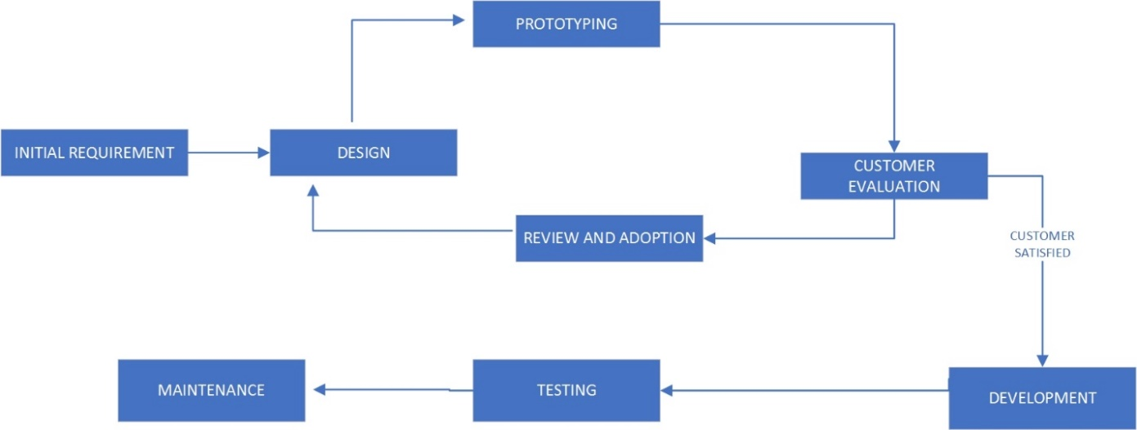

Diagram 1: Prototype model

#### Hardware Requirements

* Processor: Intel core i5
* Ram: 8GB
* Hard disk: 250 GB SSD

#### Software Requirements

* Android Studio
* MySQL database
* Microsoft Server 2016
* HTML and PHP

### Architecture of The System

The systems Architecture is the conceptual model that defines the structure, behavior, and more views of a system. An architecture is a formal description and representation of a system, organized in a way that supports reasoning about the structures and behaviors of the system

There are different types of system architectures but for the purpose of this project and the type of system under study, we will be making use of a three-tier type of system architecture which is mostly suitable for web applications.

The three-tier architecture is a client-server architecture in which the functional process logic, data access, computer data storage and user interface are developed and maintained as independent modules on separate platforms. (Marston, 2012)

The three-tier system architecture has three essential components:

1. A client PC (User)
2. An Application Server (web Server)
3. A Database Server

Diagram 2: Architecture Design

### Design of the System

### The system design includes the flow chart, use case and the database design.

### This is the blue print of the whole system which upon it, the system will be built.

#### Flow Chart of the System

The flow chart of the system is a diagram that depict the activities of the system graphically.

This shows the activities performed by the system in a step by step manner.

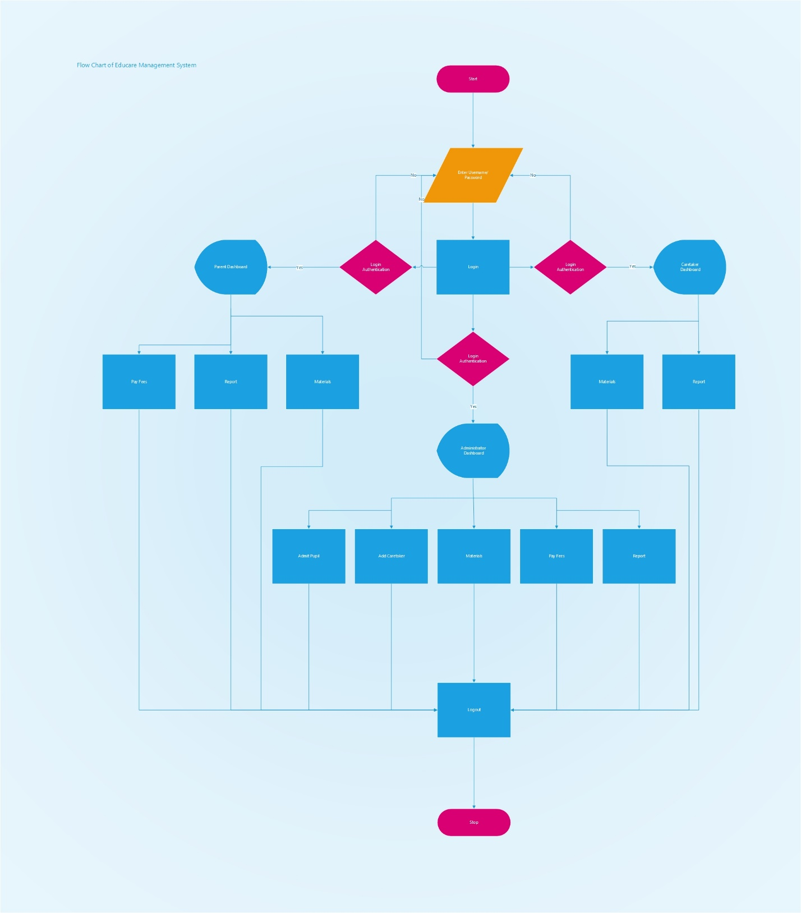

Diagram 3: Flow chart

The use case diagram shows the actors of the system and the various activities they perform

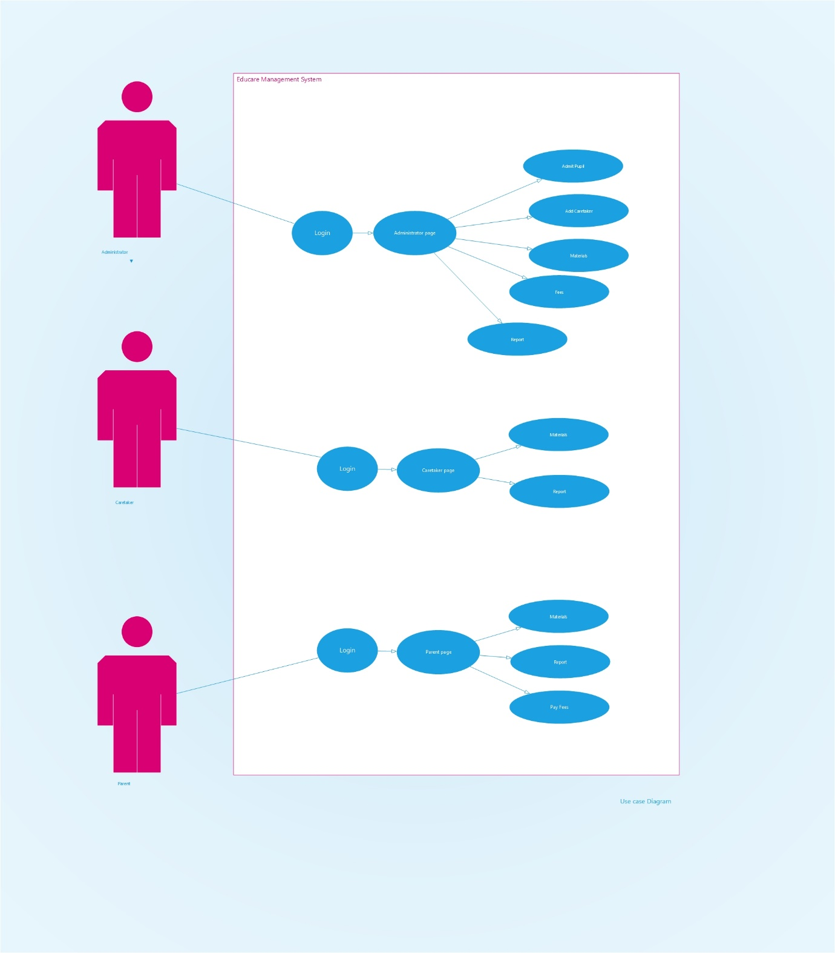

Diagram 4: Use case

#### Database Design

The database design helps to know how data will be stored into the database.

The database design includes the Entities, Attributes and the Relationships between the Entities

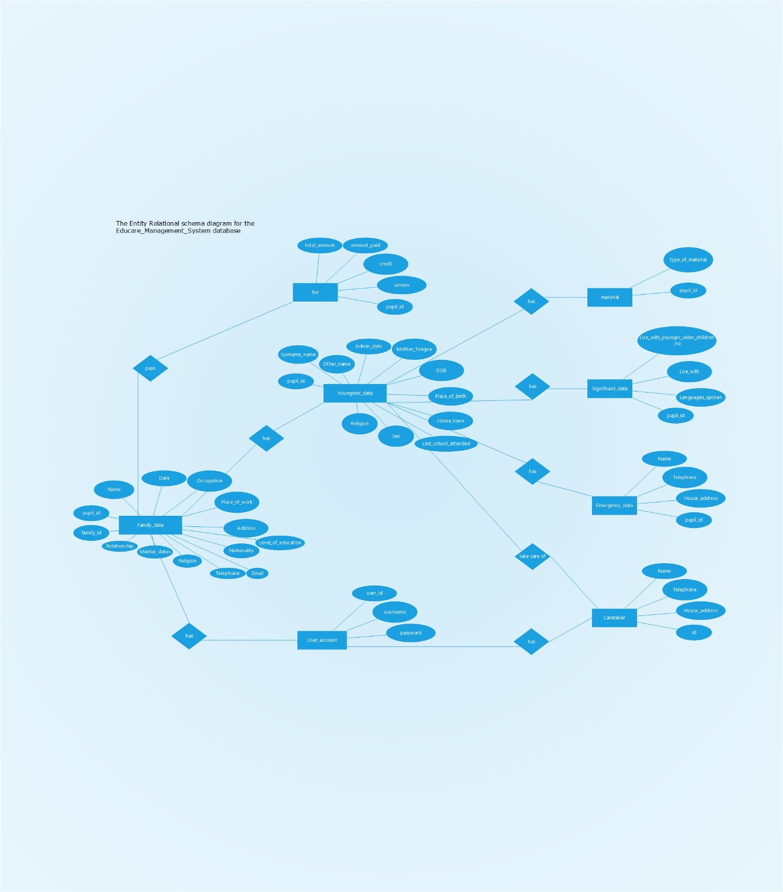

Diagram 5: ER Schema

References

(2013). Retrieved from wikipidia: https://en.m.wikipidia.org/wiki/Online_calendar

Dallat, C. E. (2007). Communicating Risk:An Insight Into, And Analysis Of, How Some Of Our Colleagues Are Currently Communicating Risk To Parents. *Wilderness Risk Management Conference.* Retrieved from https://www.outdoored.com/sites/default/files/documents/files/Program_Management_8_Dallat.pdf

Ltd., M. (. (n.d.). Retrieved from “Smart Educare” Education Management Software: http://mysoftheaven.com/product/smart-educare

Marston, T. (2012). *What is 3-Tier Architecture*. Retrieved from Retrieved from https://www.tonymarston.net/php-mysql/3-tier-architecture.html

Tadpoles. (2010). Retrieved from Childcare: https://www.capterra.com/p/118895/Childcare/

TADS. (2002). Retrieved from TADS Educate: https://www.capterra.com/p/135574/TADS-Educate/